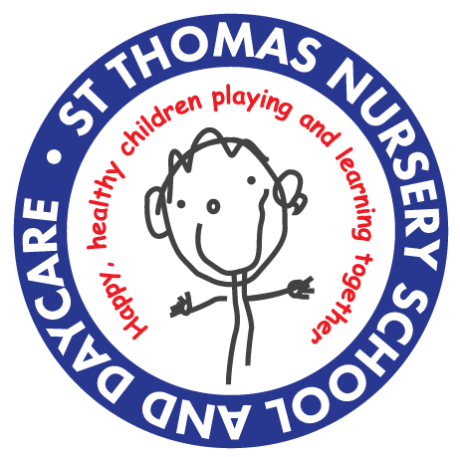
ST. THOMAS CENTRE NURSERY SCHOOL
Date………………………………
Staff ……………………………..
Waiting List
CHILD’S DETAILS - REQUIRED
Child’s first name | Child’s surname
Child’s date of birth | Child’s gender MALE FEMALE
Child’s full address

Postcode
CONTACT INFORMATION -REQUIRED
Name (Mr/Ms/Miss/Mrs)
Address/postcode
Contact telephone number
Email
OTHER INFORMATION - REQUIRED
Child lives with MOTHER □ FATHER □ OTHER □
Name of previous day care, nursery, child minder (if any)

Have you attended any of the following at St Thomas Centre? STAY & PLAY □ FAMILY TEAM □
TRAINING COURSE □ MATERNITY SERVICES□
OTHER □ ………………………………………………
OTHER INFORMATION/ADDITIONAL NEEDS/ MEDICAL CONDITIONS/ALLERGIES

PARENT’S REQUESTED PLACE – REQUIRED

We offer both fee paying places and free, local authority funded places to eligible children. Children under 2 years old will always need to pay for their space. Some eligible 2 year olds and all 3 and 4 year olds are entitled to 15 hours (2.5 days) of free provision a week during term time. 3 and 4 year old children of working parents may be entitled to 30 hours of free provision.

Free Funded Place Request – Subject to Eligibility
Requested Place | Beginning of Week  Monday & Tuesday 8.45 – 3.00  Wednesday 8.45 – 11.15AM | End of Week  Wednesday 12.30 – 3.00PM  Thursday & Friday 8.45 – 3.00
Requested Start Date
Fee Paying Space Request
 | Monday | Tuesday | Wednesday |  |  | Thursday | Friday
Breakfast Club
8AM – 8.45AM
School Day  8.45AM – 3.00PM |  |  | 8.45 – 11.15AM | 12.30 – 3.00PM | All day
After School Club
3.00PM – 6.00PM
Requested Start Date

The following questions are optional and will help us get to know you and your family. This information will help us to see whether we can offer you any additional support or funding. You will still be considered for a place even if you choose not to answer.
Does your child have a Child Protection Plan, or is subject to a section 47 Child Protection investigation, or a section 17 Children in Need plan? | Yes | No

WHO KNOWS YOUR CHILD? | YES/NO | Name & Contact Details
Health Visitor

Family Support Worker

Social worker

Speech Therapy

Other e.g. Hospital, CDC

I give my consent for the Nursery to contact the professionals above about my child using the contact details provided. Please tick: □
2-YEAR-OLD PLACE CRITERIA- You must answer these questions to be considered for a free 2-year-old place. If you answer ‘Yes’ you will be asked to complete an online eligibility check.

Do you receive any of the following benefits?
Universal Credit - if you and your partner have a combined income from work of less than £15,400 a year after tax | Yes | No
Tax credits and you have an annual income of under £16,190 before tax | Yes | No
Income Support | Yes | No
Income-based Jobseeker's Allowance (JSA) | Yes | No
Income-related Employment and Support Allowance (ESA) | Yes | No
The guaranteed element of State Pension Credit | Yes | No
Support through Part VI of the Immigration and Asylum Act 1999 | Yes | No
Working Tax Credit 4-week run on (the payment you get when you stop qualifying for Working Tax Credit) | Yes | No
You are Zambrano Carers | Yes | No
You are a family with no recourse to public funds with a right to remain in the UK on grounds of private/family life | Yes | No
Your child is a child of a subset of failed asylum seekers | Yes | No

30 HOUR PLACE CRITERIA FOR 3/4 YEAR OLDS You will need to complete an online application in order to claim.
 | Do you work 16 hours or more a week? |  | Are you unable to work because you or someone you care for is sick or disabled? |  | Is your income less than £100,000 a year? |  | If you are in the UK on a visa, do you have recourse to public funds?
About you | Yes | No | Yes | No | Yes | No | Yes | No
About your spouse/partner, if you have one | Yes | No | Yes | No | Yes | No | Yes | No

This information is being collected to administer your child’s progress through the education system. It may be shared with Birmingham City Council, the Department for Education, relevant health and welfare practitioners, and other schools with whom your child may become associated.
By ticking below, I give my consent for the information I have provided to be used in the following ways:
To contact me about a Nursery place for my child: □
To contact me about other activities on site: □
To be kept on file until a place can be offered and/or my child is too old for Nursery provision: □
To be shared with other agencies or professionals as required: □
YOU MAY ASK FOR THIS INFORMATION TO BE UPDATED OR DESTROYED AT ANY TIME BY CONTACTING THE NURSERY OFFICE.

Name of Person Completing Form……………………………………………………………………………………………..

Signed ………………………………………………………………… Date…………………………………………………………

